**Selenium WebDriver**

1. Selenium WebDriver is the most important tool/component of Selenium suite.
2. Selenium WebDriver API provides communication facility between languages and browsers.
3. The following image shows the architectural representation of Selenium WebDriver.

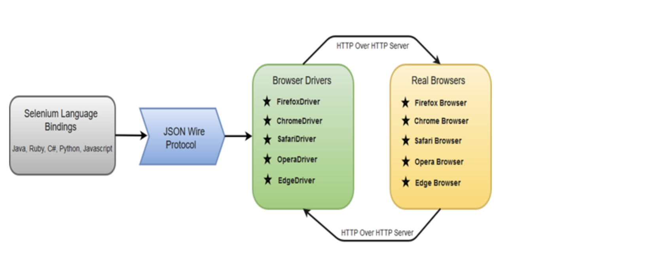

There are four basic components of WebDriver Architecture:

1. **Selenium Language Binding/Selenium Client Libraries:-** Selenium developers have built language bindings/Selenium Client Libraries in order to support multiple languages. For instance, if you want to use the browser driver in java, use the java bindings.
2. **JSON WIRE Protocol :-** JSON wire protocol acts as a mediator between client libraries and WebDrivers. It sends transfers data between the client and the server on the web. The server doesn't understand the programming language in which the program is created, it just understands the protocol, and here comes the role of JSON wire Protocol.
3. **Browser Driver :-** Selenium uses drivers, specific to each browser in order to establish a secure connection with the browser without revealing the internal logic of browser's functionality. The browser driver is also specific to the language used for automation such as Java, C#, etc.
4. **Browsers**

Browsers supported by Selenium WebDriver:

* Internet Explorer
* Mozilla Firefox
* Google Chrome
* Safari
* **Simple Commands**: Most of the commands used in Selenium WebDriver are easy to implement. For instance, to launch a browser in WebDriver following commands are used:  
  WebDriver driver = new ChromeDriver() for chrome browser

**WebDriver driver = new FireFoxDriver() for mozilla browser**

* **WebDriver- Methods and Classes**: WebDriver provides multiple solutions to cope with some potential challenges in automation testing.  
  WebDriver also allows testers to deal with complex types of web elements such as checkboxes, dropdowns and alerts through dynamic finders.